Triston Luzanta

MatLab Project 3

ECE 2523

Dr.MetCalf

Part 1:



There are 6 cases for the home winning teams [HH, HVH, VHH, VV, VHV, HVV]. Where H is the home team and V is the other team. Let H = P and V = (1-P).

Cases for home winning team best of 3:

HH = P x P = P2

HVH =P x P x (1 – P) = P2 – P3

VHH = (1 – P) x P x P = P2 – P3

By adding up all the cases we get 3P2 – 2P3.

Cases for home winning team best of 1:

VHV = (1 – P)2 x P = P - 2P2 + P3

HVV = (1 – P)2 x P = P - 2P2 + P3

By adding up all the cases we get 2P - 4P2 + 2P3.

Above is the graph of these derivations where p is 0 ≤ p ≤ 1. As the probability values get closer to 1 the separation of the two traces become greater. When p = 0.9 and 1 is when the traces shows the greatest separations.

Part 2:







Based on this experiment, I would say that using the Empirical PMF data would be better to analyze the data. This is because the empirical probability is the actual probability of an event resulting from an experiment, while the estimated probability is estimation where there are more possible outcomes and these outcomes may never occur.

|  |  |
| --- | --- |
| Time of Day | λ |
| Morning | $$\frac{1 }{3600}$$ |
| Lunch | $$\frac{1}{1200}$$ |
| Evening | $$\frac{1 }{720}$$ |

λ calculations:

α = λ T

where α = 1, 3, 5 and T = 1 hour = 3600 seconds

λ = $\frac{α }{T}$ = 1 $\frac{1 }{3600}$* = $\frac{1 }{3600}$/ s

λ = $\frac{α }{T}$ = 3 $\frac{1 }{3600}$* = $\frac{3}{3600 }$ = $\frac{1}{1200 }$/s

λ = $\frac{α }{T}$ = 5 $\frac{1 }{3600}$* = $\frac{5}{3600}$ = $\frac{1}{720 }$/s

Appendix:

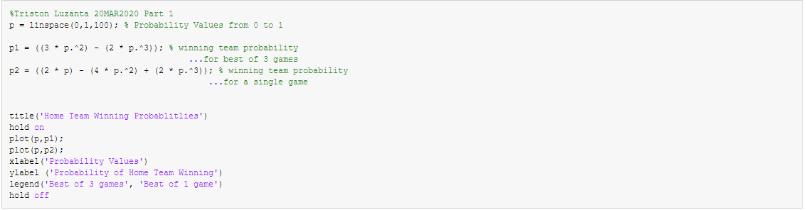Part 1:

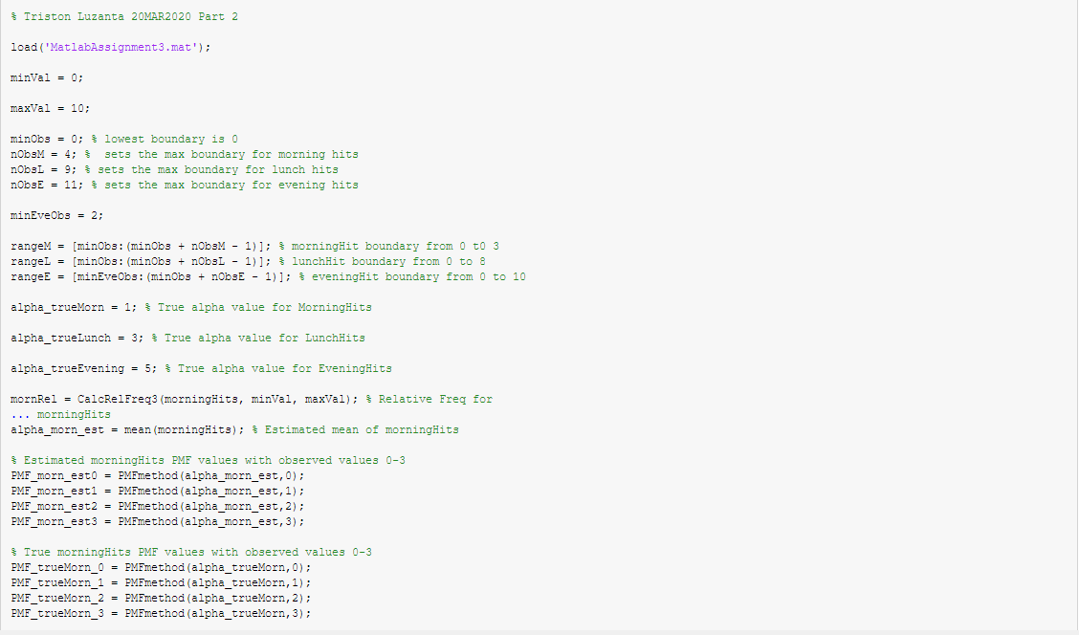Part 2:

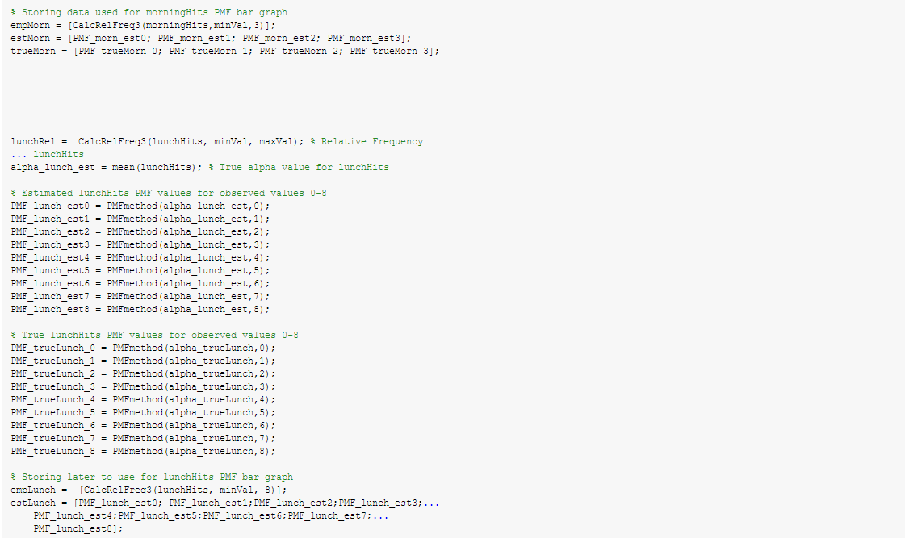

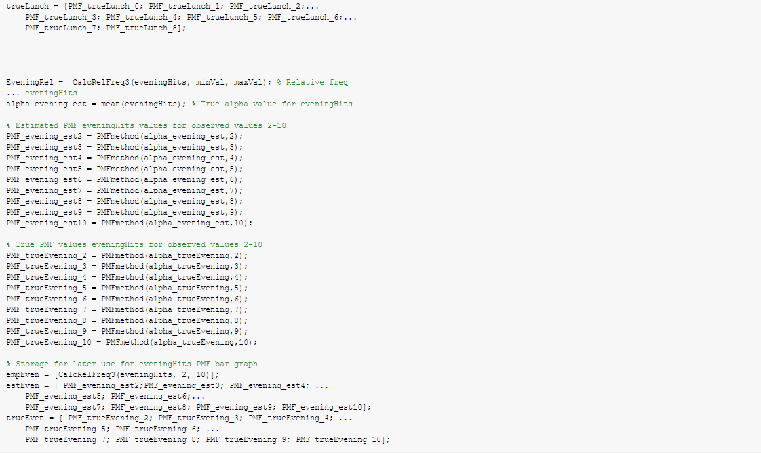



PMF Method:

